Amendment to Sailing Instructions #2, 4/9/2018

ADD
- Sailing Instruction 1.8

Add CBS 5.8c

“When the umpires observe that a collision course may be imminent and they give advice, other than “Collision Course”, to either boat as to how to prevent a collision, then a boat shall be penalised. There may be additional penalties related to the incident”.

- Sailing Instruction 1.9

Add CBS 5.8c to the list of penalties listed in CBS 8.2

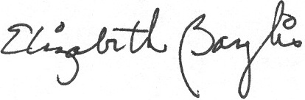
Signed: Liz Baylis
World Sailing Technical Delegate

