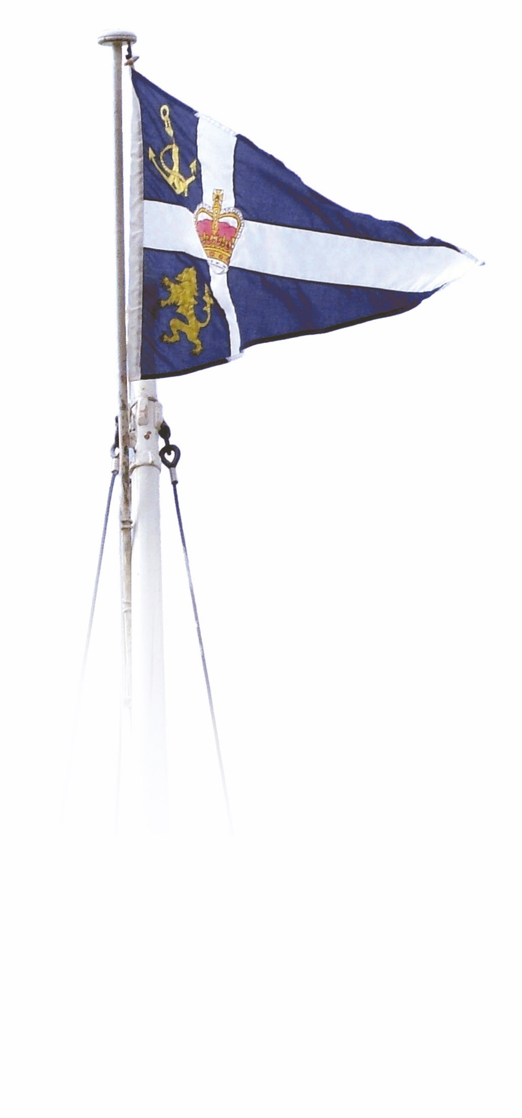 

**Royal Northern & Clyde Yacht Club**

**707 Scottish Championships**

**Saturday 24 and Sunday 25 October 2020**

**Notice of Race**

**The Organising Authority (OA) is Royal Northern & Clyde Yacht Club**

**1 RULES**

**1.1** The regatta will be governed by the rules as defined in The Racing Rules of Sailing (RRS) and the Hunter 707 Class Rules.

**1.2** Boats must comply with Class Association Rule 7.1(v) – ‘An outboard motor of minimum weight 13kg carried in the cockpit engine housing or a metal weight of not less than 13kg fixed in the cockpit engine housing’.

**1.3** Boats without engines must carry 2 paddles/oars as an alternative means of propulsion.

**1.4** The Sailing Instructions may also change some RRS.

**2 ADVERTISING**

**2.1** Competitor advertising will be restricted as follows; any advertising of any other regatta or

regatta sponsor shall be removed prior to the first day of racing.

**2.2** Boats may be required to display advertising chosen and supplied by the OA.

**3 ELIGIBILITY AND ENTRY**

**3.1** The regatta is open to all boats of the Hunter 707 class.

**3.2** Eligible boats may enter by completing the online entry form at:

[www.rncyc.com/event-information](http://www.rncyc.com/event-information)

**4 FEES**

**4.1** The entry fees for the regatta are £50 per entry.

**4.2** To complete entry, fees must be paid by BACS to RNCYC. Bank details are Sort Code: 80-22-60. Account No: 10499968. Please use 707 and sail number of the entry as the reference.

**5 SCHEDULE**

**5.1** A radio briefing will be broadcast on Channel 77 at 09:30 hours on Saturday 24 and Sunday 25 October 2020.

**5.2** 4 races are scheduled on Saturday and 3 on Sunday.

**5.3** The scheduled time of the warning signal for the first race each day is 10:25 hours.

**6 SAILING INSTRUCTIONS**

**6.1** The sailing instructions will be available for download from [www.rncyc.com/event-information](http://www.rncyc.com/event-information) from 10 October 2020.

**6.2** The sailing instructions may be subject to amendment on Government advice or requirement.

**7 VENUE**

**7.1** The regatta venue is Royal Northern & Clyde Yacht Club and Rhu Marina, by Helensburgh.

**8 THE COURSES**

**8.1** The courses to be sailed will be windward/leeward type courses.

**9 PENALTY**

**9.1** The penalty for a breach of a rule, other than a rule of Part 1 and 2 of the Racing Rules of sailing, may, at the discretion of the protest committee, be less than disqualification. This changes RRS 64.1 and RRS A4.2.

**9.2** The first two sentences of Rule 44.1 are changed to “a boat may take a One – Turn Penalty when she may have broken one or more rules of Part 2 or Rule 31 in an incident while racing.”

**10 SCORING**

**10.1** Three races shall be completed to constitute a series.

When *five or fewer* races have been completed, a boat’s series score shall be the total of her race scores.

When *six* or more races have been completed, a boat’s series score shall be the total of her race scores excluding her worst score.

**11 RISK STATEMENT**

**11.1** Rule 4 of The Racing Rules of Sailing states: "The responsibility for a boat’s decision to participate in a race or to continue racing is hers alone."

**11.2** Sailing is by its nature an unpredictable sport and therefore inherently involves an element of risk. By taking part in the event, each competitor agrees and acknowledges that:

(a)They are aware of the inherent element of risk involved in the sport and accept responsibility for the exposure of themselves, their crew and their boat to such inherent risk whilst taking part in the event;

(b) They are responsible for the safety of themselves, their crew, their boat and their other property whether afloat or ashore;

(c) They accept responsibility for any injury, damage or loss to the extent caused by their own actions or omissions;

(d) Their boat is in good order, equipped to sail in the event and they are fit to participate;

(e) The provision of a race management team, patrol boats and other officials and volunteers by the event organiser does not relieve them of their own responsibilities;

(f) The provision of patrol boat cover is limited to such assistance, particularly in extreme weather conditions, as can be practically provided in the circumstances.

(g) It is their responsibility to familiarise themselves with any risks specific to this venue or this event.

(h) They are responsible for ensuring that their boat is equipped and seaworthy so as to be able to face extremes of weather; and that the safety equipment is properly maintained, stowed and in date and is familiar to the crew.

**12 INSURANCE**

Each participating boat shall be insured with valid third-party liability insurance with a minimum

cover of £3,000,000 or the equivalent.

**13 PRIVACY STATEMENT**

**13.1** The personal information you provide to the organising authority will be used to facilitate your participation in the event. If you have agreed to be bound by the Racing Rules of Sailing and the other rules that govern the event (the rules), the legal basis for processing that personal information is contract. If you are not bound by the rules, the legal basis for processing that personal information is legitimate interest. Your personal information will be stored and used in accordance with the OA’s privacy policy. When required by the rules, personal information may be shared with the RYA and/or World Sailing. The results of the event and the outcome of any hearing or appeal may be published.

**14 FURTHER INFORMATION**

For further information please contact: Neill Ross [neill@neillross.co.uk](mailto:neill@neillross.co.uk)

***OTHER INFORMATION***

**Marina**: fees and craneage need to be arranged directly with Rhu Marina, tel: 01436 820238, email: [rhu@boatfolk.co.uk](mailto:rhu@boatfolk.co.uk). An inclusive package has been negotiated which includes lifting in and out and two nights berthing for £149.

Please note that craning in is only available between 13:30hrs and 17:00hrs on Friday 23rd October

**Prizegiving**: there will be a prizegiving as soon as possible after racing on Sunday at the Clubhouse RNCYC. The OA hopes that this can be completed before 16.00 when the tide rise is sufficient for lift out at Rhu Marina.

**Social:** a buffet meal will be available at RNCYC on Friday 23rd and Saturday 24th October. **T**he price will be £15 for Saturday only or £25 for both evenings. Advance booking will be required.

**Camping**: limited camping will be available by prior arrangement. Please contact Neill Ross [neill@neillross.co.uk](mailto:neill@neillross.co.uk)